Title (Capitalize Each Word)

First Author^{1*}, Co-author¹, Co-Author², Co-Author²
(Spell full name and email address of all authors, kindly highlight & bold the corresponding author)

¹Affliation and full address
Email: firstauthor@y.com*; co-author@y.com

²Affliation and full address
Email: coauthor@x.com; coauthor@x.com

Abstract
Text starts here…

Keywords: Max 5 related keywords

1 Introduction

Text [1] starts here (Any figure or table that stated in this text should be placed on the last page as shown in this template)…

2 Methodology

Text [1] starts here (Any figure or table that stated in this text should be placed on the last page as shown in this template)…

3 Results and Discussion

Text starts here (Any figure or table that stated in this text should be placed on the last page as shown in this template)…

4 Conclusion

Text starts here …

Acknowledgement

Text starts here…

References

- Meilinger A. and Torok I. (2013) The Importance of Friction Stir Welding Tool, Prod. Process. Syst., vol. 6, no. 1: 25–34

(Refer attachment provided)

Compile all figures and tables on the last section.

List of Figure Captions

Figure | Caption
Figure 1 | Sample 1
Figure 2 | Sample 2

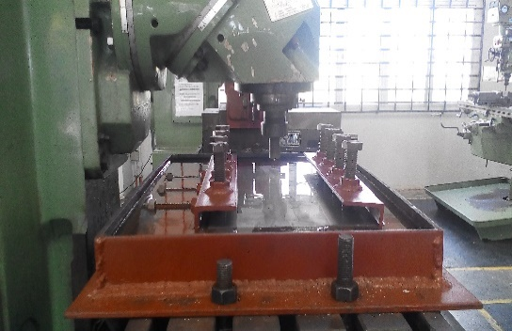
Figure 1: Sample 1 (Example)

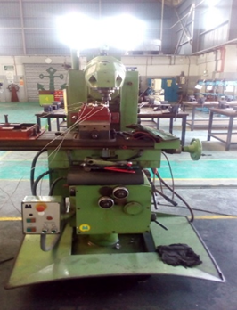
Figure 2: Sample 2 (Example)

List of Table and Caption

Table | Caption
Table 1 | Sample 3

Table 1: Sample 3 (Example)
Welding Parameters
Specimen | Rotational Speed (RPM) | Travel Speed (mm/min) | Travel Direction
1 | 1600 | 16 | Backward
2 | 1600 | 16 | Forward
3 | 910 | 16 | Backward
4 | 910 | 16 | Forward

IMPORTANT REMINDER

If figures/diagrams are taken (i.e., simply copied) from any other publication (e.g. book or journal), there is a written permission required. The corresponding form to request this permission from the corresponding publisher is attached.

In addition, each figure caption must contain the following statement then:

“Reprinted with permission from XXX publishers”/“printed with permission from XXX”.

Alternatives:

- to redraw the figure/diagram where possible (then only the classical reference as a number in squared brackets is required in the figure caption)

- to take a figure from a Springer publication (= the same publisher). Then there is no need for a written permission based on the attached form but the following statement must be included in the figure caption: "Reprinted with permission from SpringerNature publishers".

The publisher is checking each figure and they will not proceed a manuscript if this is not properly done.

